Output Screenshots

**Team Members**:

Nitheesh Kumar N - 205001070

Mukilesh S – 205001306

The First Page of the program will have the login form where the user must enter their username and password to login to their account

As per the input to username and password the user is directed to their respective page.

The admin can set 5 questions for the survey if he clicks on to “Create Poll” button

Each question can be clicked on to set the question. The question set up page looks as follows:

The admin can also view poll results for the created 5 questions for the survey if he clicks on to “View Results” button

By clicking on to the question button admin will be able to see the result bar graph according to the polls given by user.

After viewing the results or setting up 5 questions the admin can close the question/ answer palette and go back to dashboard to logout and leave the page. After logging out the user is redirected to the login form again where the user can always re-enter with their login credentials.

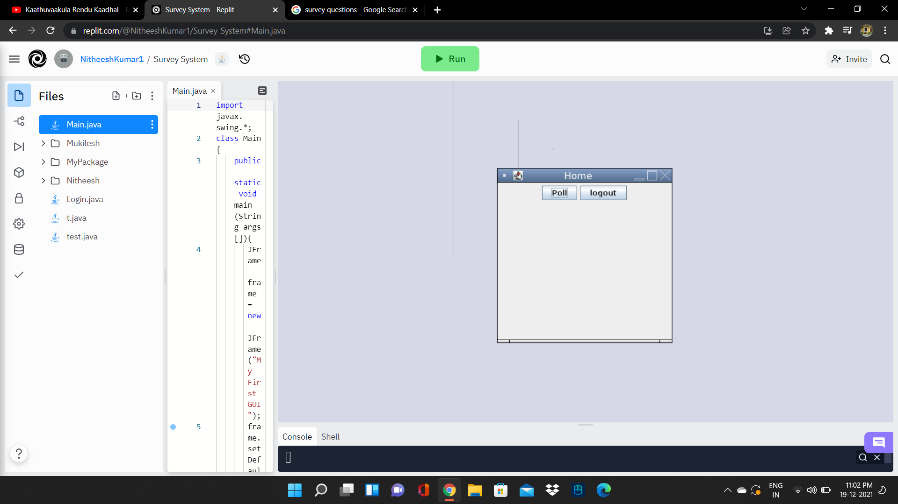User page looks as follows:

The user can poll for the 5 questions set up by admin by clicked on to the “Poll” button. Options are shown as a drop down menu for the user.

If the username or password doesn’t match the following page is displayed.

